**LOCKCHAINS’ DISTRIBUTED COLLABORATIVE ENTITY: A NEW MULTI-STAKEHOLDER CORPORATE GOVERNANCE MODEL**

**Introduction**

You hear a lot about governance in the Ethereum community. There’s a common sentiment:

*We desperately need a better governance model, or Ethereum will fail to scale – or worse, it will scale but become a decentralized machine of corruption and social manipulation.*

At Blockchains, we’re faced with similar concerns. We’re trying to build a smart city to incubate blockchain and other advanced technologies – and use it to prove to ourselves and others that a better world is possible. If successful, we hope individuals and organizations might be inspired by our example and that the technologies built here will allow them to follow suit.

We know that’s a tall task; we’re idealistic, not naive. Our mission requires significant innovation, adaptability, and resilience – and it requires coordination and collaboration among municipalities, organizations, and businesses, all with varying purposes and responsibilities. So how do we effectively accommodate the interests of multiple independent entities while maintaining commitment to our purpose? How do we structure governance to promote adaptability and innovation? How do we prevent the need for growth and the love of power from corrupting our mission from the inside out?

We’ve got some ideas, but we don’t have all the answers. We want your feedback as we publicly document the development of the governance model behind the world’s first distributed collaborative entity (DCE). For this reason, we’re choosing to be as transparent as is reasonably possible from the start. Over the coming months, we’ll publish a series of posts specifying our roadmap and methods; providing development updates; and making formalized means available for interested community members to offer feedback and ask questions.

For now, let me invite you into our process and orient you to our perspective.

**The Failures of Big Tech**

Ethereum, and the blockchain community more broadly, is deeply familiar with the ways in which Web 2.0 has failed us. Centralized services run by organizations with opaque power structures, black-boxed code, and profit-motivated venture capitalists and shareholders have created systems where our personal information is vulnerable to attacks and mismanagement. Worse, ever-accelerating profit growth stands before the welfare of humans and our planet.

In the existing system, there’s rarely a clear way to voice concern and influence change from within, leaving unsatisfied users (and employees) no option but to boycott, protest, or leave. But that’s difficult because many software platforms, especially social media, are designed to manipulate emotions in a way that makes users reliant upon them. The addictive capacity of these technologies is a widely acknowledged fact within software development communities, but ethics often get lost in the race to develop new technologies quickly and drive profits. Even if someone has the will to stop using these platforms, some technologies have become so ubiquitous that it’s nearly impossible to exit them completely.

It’s also true these technology companies have contributed enormously to the world by offering accessible, affordable information, products, and services. Thanks to the innovations of their founders and employees, we can now easily communicate, connect, and trade with people across the globe, allowing for an unprecedented proliferation of collaboration and innovation. We’re far from techno-pessimists. The power unleased by Web 2.0 can hardly be overstated, and we think it has provided the foundation for a collaborative, free, and open future. We’re just not there yet. First, we need to address governance.

**Profit-Motivated Stakeholder Rule**

At Blockchains, we think some of these systems’ negative impacts result from the incentives that motivate decision makers to structure their systems this way. To understand why, it’s helpful to look at how public corporations are typically structured. Below is an organizational chart of a standard public corporation:

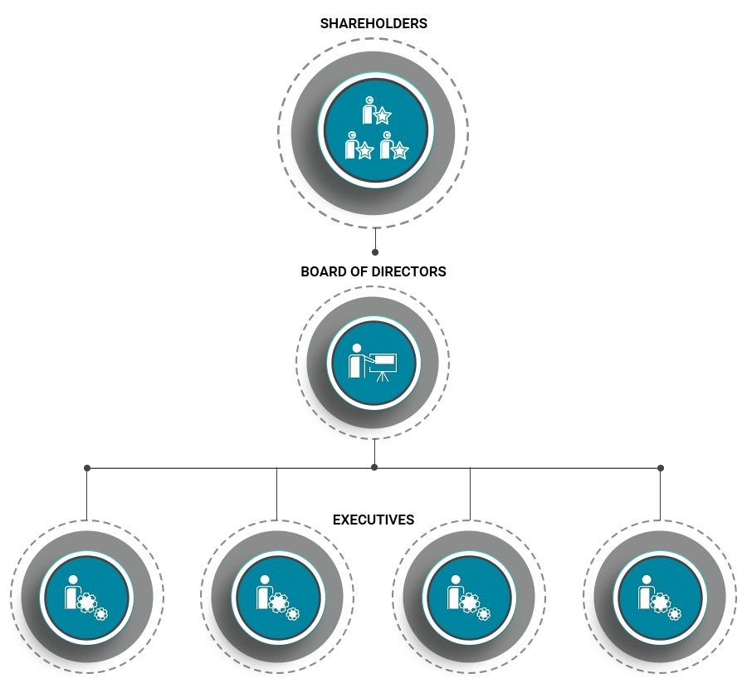

Most corporations concentrate power at the top, where the CEO and board of directors (usually consisting of the CEO, other senior executives, and third parties) make major decisions related to strategies, policies, budgets, and executive-level hiring. Under this model, the board is appointed by stockholders, comprising venture capitalists, employees, founders, and (in the case of a public company) institutional investors. Either way, individual shareholders have little power. In short, if a corporation is private, it’s likely controlled by big-time initial investors and founders. If a corporation is public, it’s controlled by institutional investors and probably its founders.

The board’s responsibility is to maximize the value of stocks on behalf of the stockholders. In most cases, stockholders can sue the company for not upholding its fiduciary responsibilities, which require the board to act (in a way reasonable people would believe to be) in the financial best interests of the company. The exception here is so-called “benefit corporations,” which have a legal obligation to prioritize environmental and/or social good, as well as legal protections to prioritize long-term value over short-term shareholder profits. However, specific protections vary between states, and almost no benefit corporations are public companies.

It turns out that even when shareholders are granted legal protections, the influence of their financial interests is outsized. This is in part because the company relies on shareholders for funding; if the shareholders are dissatisfied with the board enough to sell, coupled by a decrease in stock value, this can hurt the company’s ability to raise money in future offerings. Plus, since shareholders elect the board, they’re the only formally represented stakeholder group (other than the board itself) in the corporate governance process.

This isn’t to imply a company shouldn’t focus on profits – of course, money must be made to successfully provide jobs, products, and services – but that financial self-interest shouldn’t be the only motivation around which world-shaping companies are built. *When it comes to building the technologies of our future, there’s so much more at stake than profit.*

While it’s certainly true there are a lot of corporations that actively consider the impact of their business and that may even exist primarily to benefit their communities, it’s also evident that the way these companies are structured concentrates decision-making power at the top, imparting an enormous responsibility to recognize, appreciate, and accommodate the interests of diverse – and potentially conflicting – stakeholder groups. Having a small number of decision makers makes it difficult for outcomes to reflect the interests of the people affected by decisions, regardless of good intentions. It’s also true that the people responsible for imparting these individuals with that power are organized around, and motivated almost entirely by, financial self-interest.

**Stakeholders: Beyond Financial Self-Interest**

One problem with benefit corporations is that they attempt to remedy, with good intentions, a governance model unequipped to meaningfully consider the interests of diverse stakeholders by using an incentive model fundamentally misaligned with the public good.

At Blockchains, we seek to form relationships, incubate technologies, and build new systems of organizational coordination to create a meaningfully better option than existing institutions. We think that if more transparent, dynamic systems for various stakeholder groups to make decisions affecting shared resources were more common, then the world might be a much better place. Imagine if there were formalized systems for myriad stakeholder groups – possessing their own motivations and responsibilities – to exercise their voice and collaborate around decision-making such that more interests were considered and weighted fairly.

What if major tech companies weren’t controlled by individuals and institutions focused primarily on advertising dollars and profits but instead by users, digital ethics groups, and employees? We believe those companies would be much more human-friendly.

**Multi-Stakeholder Governance**

To address the woes we see in the tech industry, and their rootedness in the dominant corporate governance model, Blockchains is creating the world’s first distributed collaborative entity (DCE) – a new multi-stakeholder corporate governance model to formalize governance at the stakeholder level.

Blockchains believes formalizing governance in this way will best allow groups to organize according to, and advocate for, their interests when the board makes decisions about shared resources. More concretely, consider the interests of workers for a software company in contrast to customers: Employees might be most interested in fair compensation, opportunities for career growth, and benefits packages, whereas customers might be more concerned with affordable prices and cybersecurity. In a multi-stakeholder model, each group might have a representative to coordinate with the representatives of other stakeholder groups such that everyone’s needs are considered when specifying DCE-level organizational purpose and priorities.

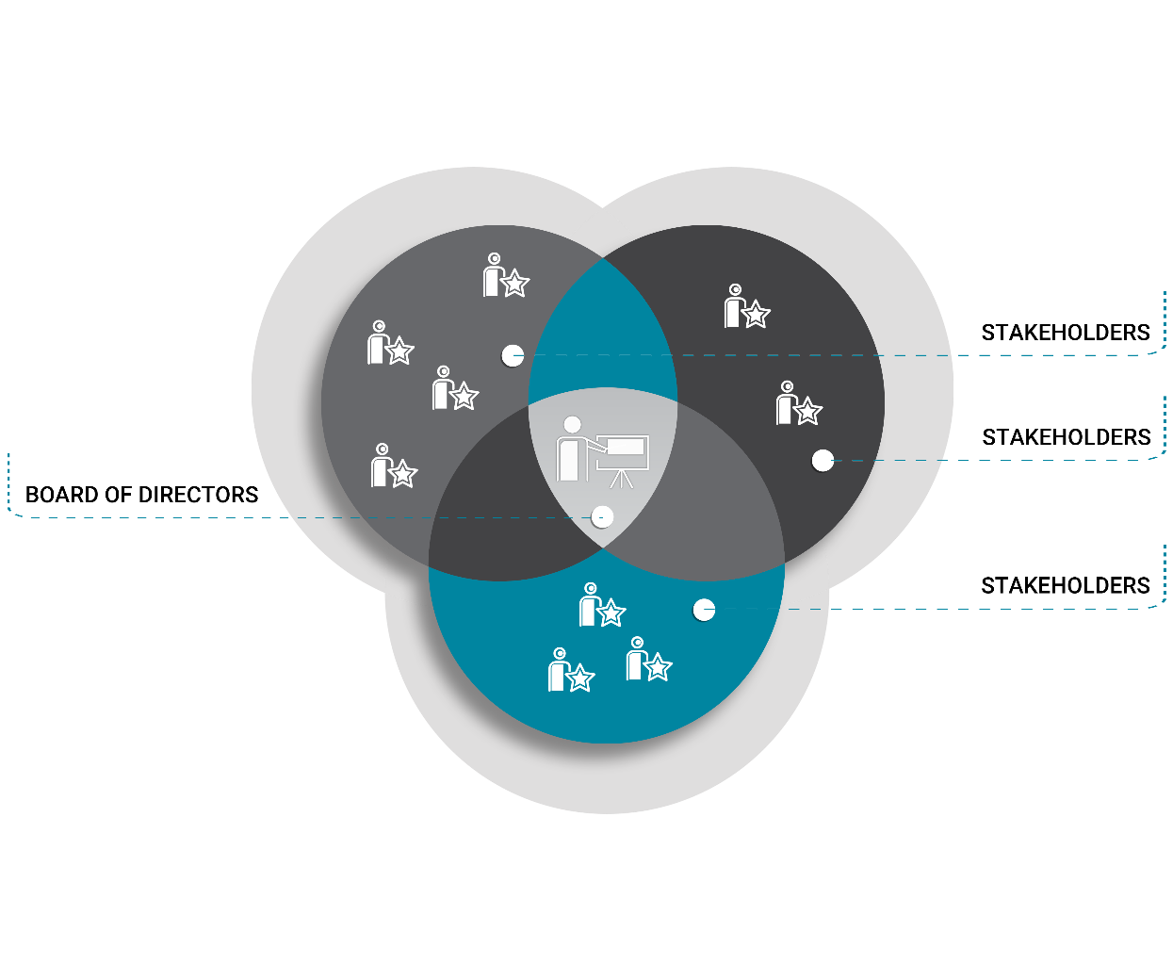

Further, a formalized multi-stakeholder governance model would allow for localized decision-making on resource distribution, meaning fewer universal decisions would need to be made in the first place and, therefore, enabling greater autonomy and agility while reducing conflict and other frictions. For example, if every stakeholder group were given some portion of the company’s profits, each group could decide independently how it might manage that budget. Consider a company with formalized decision-making protocols for various teams or projects; decisions could be made quicker and more individualized if the decision makers were those familiar with the problems and the dynamics of their teams. If all these teams were also given representation at the organizational level, they would be best equipped to speak to project-specific challenges the company could lend its resources to.

You can think of this model as similar, in some respects, to the European Union. Some resources and decisions are universal, while others are up to individual countries; each country has an internal government run by elected representatives, while every country is also represented at the supranational EU level.

**Blockchain for Trust-Minimized Cooperation**

As you might expect, here at Blockchains we’re kind of enamored with blockchain technology. But we’re not maximalists; we believe blockchains will change the world, but that doesn’t mean they offer a good solution to every problem. Some parts of DCE governance probably don’t belong on a blockchain, and we’re not going to force everything on chain just to say we did.

We do think, however, that there are a lot of properties of public blockchain technology that can benefit the multi-stakeholder model: self-enforceable contracts for dispute avoidance, decentralized arbitration for dispute resolution, asset-level governance, transparency of resource distribution and budgeting, and cross-border coordination, to name a few.

Before we get to all that, we need to identify who our stakeholders are, what decisions need governing, which stakeholders should handle which decisions, and how those decisions should be made – and those aren’t questions we seek to answer overnight. We think they’re hard questions with complicated answers that no one person should be responsible for answering. We expect that the complexity of the relationships between stakeholder groups and the resources they must manage will be significant. Further, we anticipate that the stakeholder groups will change over time, so our governance process must be adaptable and amendable. Nuance takes time.

For now, stay posted for updates. In the spirit of transparency and collaboration, we’ll be publishing a series of blog posts documenting the development process, and we invite you to offer any feedback or constructive criticism. Over the coming months, we’ll be systematically working toward answers to foundational questions: Who are the Blockchains stakeholders? What are their responsibilities, rights, and motivations? What are their relationships to each other and to Blockchains? Which decisions should each group govern individually, and when is collaboration more beneficial? Once established, we’ll open the development of specific, nuanced decision-making protocols – as well as the development of automatically enforceable agreements and other software – to more formalized community collaboration via GitHub.

Until then, contact us with any feedback or questions!

*Alison Berreman is a member of the Collaboration & Product Development Department at Blockchains and is spearheading the company's creation of the DCE. You can reach her at aberreman@blockchains.com.*